**Game Design Studio Two**

**“Mowdown”**

**Team Four**

Report for Sprint Five

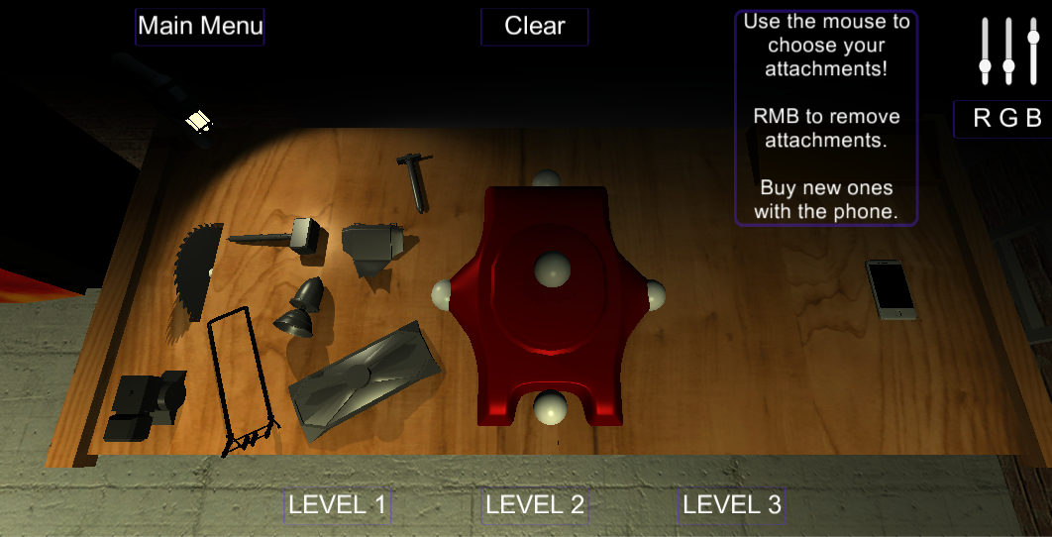12 / OCT / 2015 – 25 / OCT / 2015

**Team Members:**

Matthew Carver –12028130

Deinyon Davies – 11688025

Robert McClelland –11743693

Dinh Bao Anh (Brendan) Vo – 11437237

The most honoured Master of the Scrum,Sir Jesse Walker – 11729631

**OVERVIEW**

*Mowdown* is a ‘Demolition Derby’ or ‘Battle Bots’ style videogame, created by (in ascending alphanumeric order) Matthew Carver, Deinyon Davies, Dinh Bao Ahn (Brendan) Vo, Robert McClelland , and Jesse Walker.

Players customize one of several domestic **lawnmowers** by means of attaching defence appliances and weapons that have been unlocked and purchased by the player by means of in-game currency. Players compete against at least one autonomous opponent – a strategically formed battle-mower – as if both are controlled via Remote Control (R.C.).

Sprint Five was designed to improve the overall Quality of Life for the player as well as apply some much needed polish to the game. To this end a tutorial was added and the game loop was completed including money gain and an unlockable attachment system.

**SPRINT PLAN AND EXECUTION**

Sprint Four of Project Mowdown set out to implement nine discrete new features including (but not limited to): A new main menu, the implementation of the ‘game loop’, a basic tutorial message system and an AI that improves in difficulty as the player progresses further.

As of the preliminary Sprint Meeting, the Sprint Log proposed a **total** **estimated** investment of **2,820 minutes** – 2,530 minutes less than the estimated investment for Sprint Four – with an estimated **median** task duration of **120 minutes**. The sprint would optimistically be completed in 1,730 minutes.

This sprint focused largely on improving the quality of life for the player as well as improving the game to the point of a deliverable product rather than a presentable ‘tech demo.’ To accomplish this the team took away almost all tasks that counted as ‘adding content’ and focused on improving the content that already existed within the game. Lastly the team completely avoided adding any tasks to the sprint mid-sprint so as to avoid any ‘scope creep.’

This sprint was also during the very last few weeks of the semester; due to this several other assignments were due around this time. For most of the sprint the team was indisposed completing work for other assignments and this lowered workload helped to still complete both class’ work.

At Sprint finalisation, the Sprint Log totalled nine expected tasks. The team observed a **total** **logged** **workload** of **360 minutes** (~6 hours). Four tasks (estimated 1,340 minutes) stood incomplete or uninitiated at the time of sprint closure.

**SCRUM MEETING LOGS**

**12 / OCT / 2015**

5:00pm – 7:00pm

**Location**: UTS Building 11, Game Design Studio Laboratory

**Members present**: Brendan, Deinyon, Jesse, Matthew, Robert

The team identified backlog items and discussed time estimates.

**18 / OCT / 2015**

9:00pm – 10:00pm

**Location**: Online Group Discussion

**Members present**: Deinyon, Jesse, Matthew

The team discussed the game loop and the inclusion of experience. It was decided that due to the unforeseen difficulty of adding attachments that a ‘tech tree’ is out of scope at this point. From this the team decided to just stick with a single currency progression as oppose to one defined by a combination of experience and money.

**19 / SEP / 2015**

5:00pm – 7:00pm

**Location:** Online Group Discussion

**Members present**: Brendan**,** Deinyon, Matthew, Robert

The team discussed difficulty in completing scope items during this sprint due to other class commitments. It was decided that as this sprint is not worth any marks and that there is a week between sprint five ending and the final deliverable being due; that members should complete other assignments and work on any uncompleted sprint tasks after those assignments are completed.

Since the sprint items are relatively simple compared to the last few sprints the tasks were deemed feasible within the week after the end of sprint five.

**25 / OCT / 2015**

**Location**: Online Group Discussion

**Members present**: Brendan, Deinyon, Matt, Jesse, Robert

The team discussed the final name for the project and the name “Mowdown” was decided by a vote of 3-2. Other contenders were “Mower Mayhem” and “Lawnmower Simulator 2016.” With the name decided the main menu format and design was discussed and implemented in the project.

**BURNDOWN CHART**

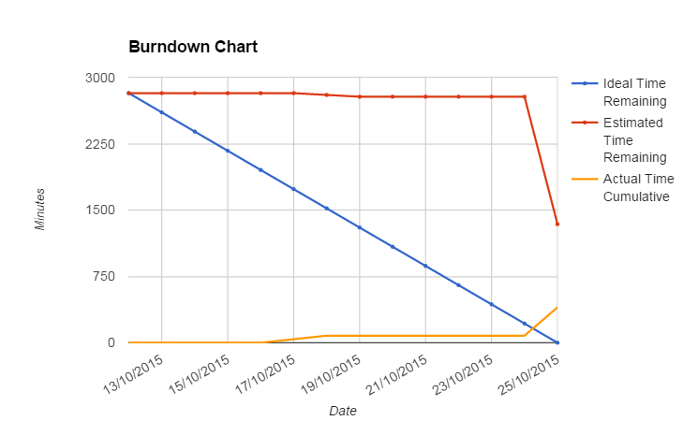

**REFLECTION**

As this sprint was scheduled on weeks 11 and 12 of this semester many other assignments were due on the same day as this sprint; Monday of week 13. Due to the lack of marks assigned to the completion of this sprint it was deemed that members should focus on any other assignments and that any tasks assigned to this sprint must be feasible within the week following the end of sprint five and before the final deliverable due date. While this does limit our feedback from classmates the changes planned in sprint five were minimal and chosen to follow design heuristics that improve player quality of life. These heuristics included the inclusion of a tutorial and a progression system. Lastly Robert McClelland scheduled external play testers during this week so as to get any feedback on the changes in time for the presentation.

While it is bad form to do so little work during a sprint the team endeavoured to ensure that the impact of this unproductive time would be minimized.

**SPECIAL CIRCUMSTANCES**

N/A

**Sprint Backlog**

|  |  |  |  |  |  |  |  |  |  |
| --- | --- | --- | --- | --- | --- | --- | --- | --- | --- |
| **User Stories** | **Acceptance Criteria** | **Assigned To** | **Task** | **Estimated Time** | **Minimum Time** | **Maximum Time** | **Actual Time** | **Completed Date** | **Completed By** |
| As a user I want a more attractive main menu | Main menu isn’t just unity buttons | Matt | Main menu isn’t just unity buttons | 130 | 80 | 210 |  |  |  |
| As a user I want the new mower which I know exists because it’s in the files | Implement new mowers | Jesse | Implement new mowers | 550 | 340 | 890 |  |  |  |
| As a developer I want a working build | Fix all the saw, the UI not hovering, The hammer , The mega purple shield | Everyone | Fix all the saw, the UI not hovering, The hammer , The mega purple shield | 550 | 340 | 890 | 60 | 25 / OCT / 2015 | Robert |
| As a user I want a game loop because right now the game is a tech demo | Game sufficiently loops with money for each win | Brendan | Game sufficiently loops with money for each win | 550 | 340 | 890 | 120 | 25 / OCT / 2015 | Robert |
| As a user i want a balanced game cuz the bot is super op | difficulty scaling with bot | Deinyon | difficulty scaling with bot | 550 | 340 | 890 |  |  |  |
| As a rob I want a button for the map hazards | Button asset | Matt | Button asset | 20 | 10 | 30 | 40 | 18 / OCT / 2015 | Matt |
| As a user I want the bot to use every type of attachment | Bot can use any attachment | Deinyon | Bot can use any attachment | 130 | 80 | 210 |  |  |  |
| As a user i want to remove attachments I've already added because i make mistakes | attachments can be removed | Jesse | attachments can be removed | 210 | 130 | 340 | 80 | 25 / OCT / 2015 | Robert |
| As a user I want a tutorial because I dont understand how anything works | Tutorial messages throughout the game | Robert | Tutorial messages throughout the game | 130 | 80 | 210 | 60 | 25 / OCT / 2015 | Robert |

**VERSION CONTROL COMMIT LOG**

commit 3a8921ba4729bff882307f17c35f521d401cac06

Author: Deinyon Davies <deinyond@gmail.com>

Date: Sun Oct 11 23:10:51 2015 +1100

Spell / Error checked report, exported PDF

commit 01523ea4d33ccba063da4178af31515d5590f3dc

Author: Matthew Carver <matthew_carver@live.com>

Date: Sun Oct 18 14:29:22 2015 +1100

TankShell and Robs Mythical Button

The base tank model without any of the extras for the moment

ButtonCap > Button > ButtonSkull

refer to the image I posted if you need to see how to put it together

commit 50acfbe6a3914e9b7987b8c18be40c173931bdf0

Author: JesseWalker11729631 <11729631@student.uts.edu.au>

Date: Fri Oct 23 22:52:02 2015 +1100

Aero model added to store, buggy in battle scene 1, Broken Atm, No mesh coll

commit 76dc1989c9c18ea52dd07e2244e79722816a7c93

Author: robafett <ram_95@msn.com>

Date: Sun Oct 25 11:04:36 2015 +1100

Clear all attachments button

commit dbd43249726b86b4d1d945001d2d0771cdc6045b

Author: robafett <ram_95@msn.com>

Date: Sun Oct 25 11:27:02 2015 +1100

Attachment Removal via RMB

commit 0c21339e92c8381dd2c5ca28c2f270dbbb6b38e6

Author: robafett <ram_95@msn.com>

Date: Sun Oct 25 12:52:11 2015 +1100

Making the Loop

commit 4088b096ee00c720161c1b78f2022d9195014a26

Author: robafett <ram_95@msn.com>

Date: Sun Oct 25 13:31:36 2015 +1100

FSM weapon use preliminary logic

commit 489459fdfe81c2f8c382a56dc403a2fa2c2c38f8

Author: robafett <ram_95@msn.com>

Date: Sun Oct 25 13:46:29 2015 +1100

Fixing the shield

commit 84ee5a42eb2d56d64de43950e094450399688d4f

Author: Matthew Carver <matthew_carver@live.com>

Date: Sun Oct 25 14:46:37 2015 +1100

Aero Repair

Repaired and reimported the AeroBase fbx

Repaired and reimported the AeroBase fbx

commit 2b9fcc3ada0f2f8ae8fa0ce2eaf218f5e77e233d

Author: robafett <ram_95@msn.com>

Date: Sun Oct 25 17:19:34 2015 +1100

Super basic tutorial messages

commit 3a3a30f5c75546d66d11a5e82bced032dcb2ec53

Author: robafett <ram_95@msn.com>

Date: Sun Oct 25 17:52:22 2015 +1100

Prelim replay code for future reference

commit 2ed2f1bb6de05a02634d4ff28c87451162c018ca

Author: robafett <ram_95@msn.com>

Date: Sun Oct 25 20:50:34 2015 +1100

Sprint Five doco

commit 2c9a71a37ab3a4f79d9d0616d7cd1cb84a2f2aba

Author: robafett <ram_95@msn.com>

Date: Sun Oct 25 22:50:02 2015 +1100

Everything but the commit log and a screen shot for the first page